Batch: D2 Roll No.:16010221038 Experiment / assignment / tutorial No.__4_____

Grade: AA / AB / BB / BC / CC / CD /DD

Signature of the Staff In-charge with date

# Title - Friction

CO1: Identify the effect of forces and moment in a given engineering system

CO3: Analyze applications of equilibrium using free body diagram

**Objective**

To measure coefficient of friction of different surfaces

**Theory**

Friction is a force that is created whenever two surfaces move or try to move across each other. • Friction always opposes the motion or attempted motion of one surface across another surface.

* Friction is dependent on the texture of both surfaces.
* Friction is also dependent on the amount of contact force pushing the two surfaces together

Static friction is friction between two or more solid objects that are not moving relative to each other. For example, static friction can prevent an object from sliding down a sloped surface. The coefficient of static friction, typically denoted as μs, is usually higher than the coefficient of kinetic friction.

**AIM:**

To find the coefficient of friction between two given surfaces and to find the load required to pull a body up on an inclined plane.

**APPARATUS:**

An inclined plane that can be set at different angles, bodies with different base materials and weights.

**Setup Diagram:**

**Free body diagram:**

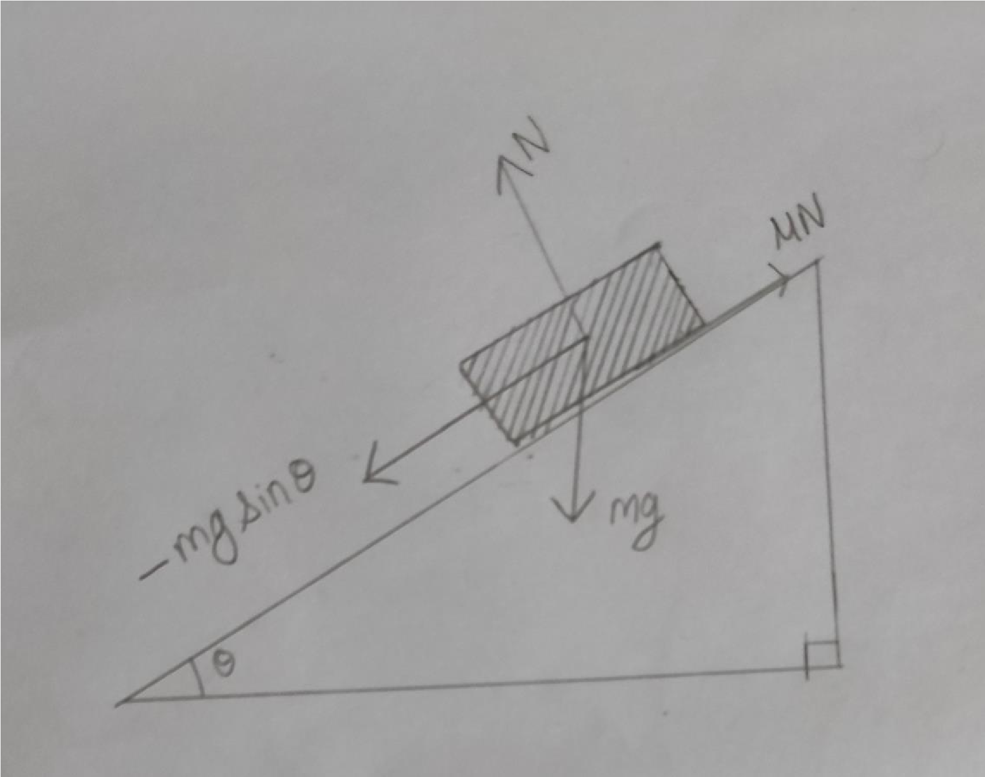

## For Angle of Repose

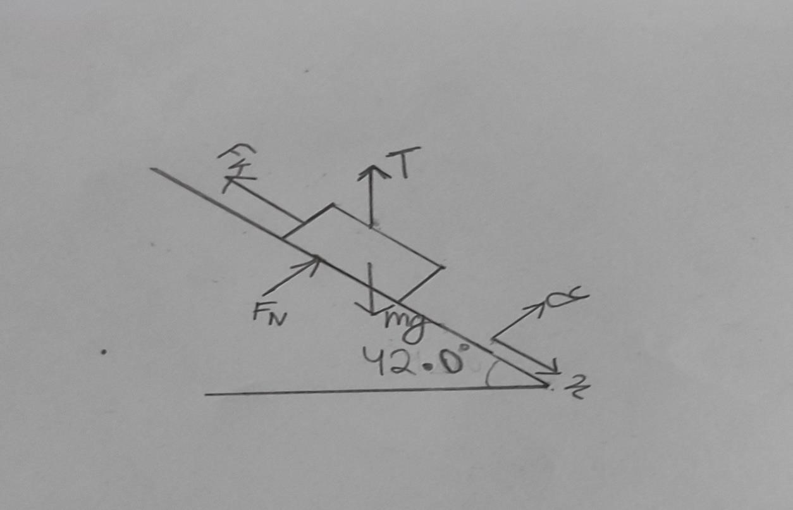

## For Experimental value of P

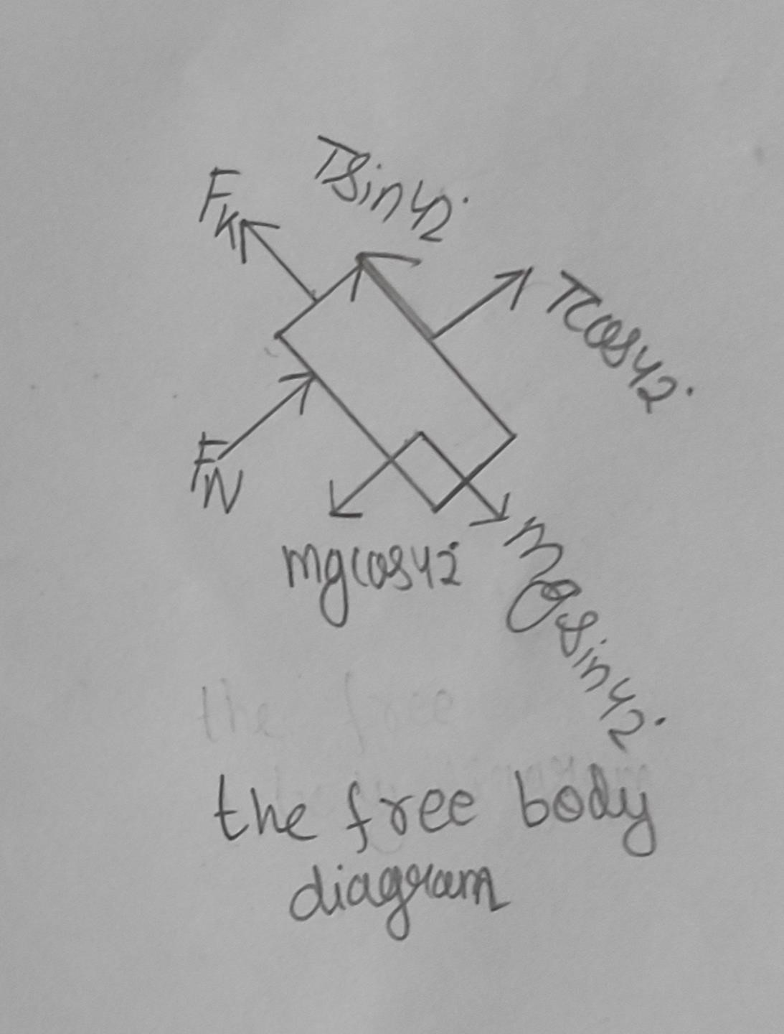

**PROCEDURE:**

**Observation 1:**

1. Keep the body on the inclined plane which is initially at the horizontal position.
2. Gradually increase the angle made by the inclined plane till the body just start sliding down.
3. Note the angle made by the inclined plane with horizontal which is angle of repose 4. Tangent of the angle of repose is the coefficient of friction between the two materials (body and the plane).

**Observation 2:**

1. Set the inclined plane at any angle. Attach the string to the body whose weight is known.
2. Place the body on the inclined plane and pass the string over the pulley.
3. Load the free end of the string with the pan and the weights.
4. Add weights to the pan till the body is tending to move up. Note the load and compare it with the calculated value.

**OBSERVATION TABLE 1**

|  |  |  |  |  |  |
| --- | --- | --- | --- | --- | --- |
| Materials |  | Angle of Repose (α) | |  | Coefficient of friction  (µ) |
| 1 | 2 | 3 | mean |
| Ply and wood | 120 | 110 | 130 | 120 | 0.21 |
| Ply and aluminium | 200 | 230 | 240 | 22.330 | 0.41 |
| Ply and brass | 190 | 200 | 200 | 19.660 | 0.35 |
| Ply and sand paper | 100 | 100 | 100 | 100 | 0.17 |

**OBSERVATION TABLE 2**

|  |  |  |  |  |  |
| --- | --- | --- | --- | --- | --- |
| Surfaces | Coefficient of friction | Weight (W) | Angle of plane  (θ) | Pth = Wsinθ  +µWcosθ | P(expt.) |
| Ply and wood | 0.21 | 250g | 250 | 152.52 | 143.48 |
| Ply and aluminium | 0.41 | 167g | 250 | 131.76 | 118.48 |
| Ply and brass | 0.35 | 288g | 250 | 211.68 | 196.48 |
| Ply and sand paper | 0.17 | 162g | 250 | 92.82 | 94.48 |

**CALCULATION:**

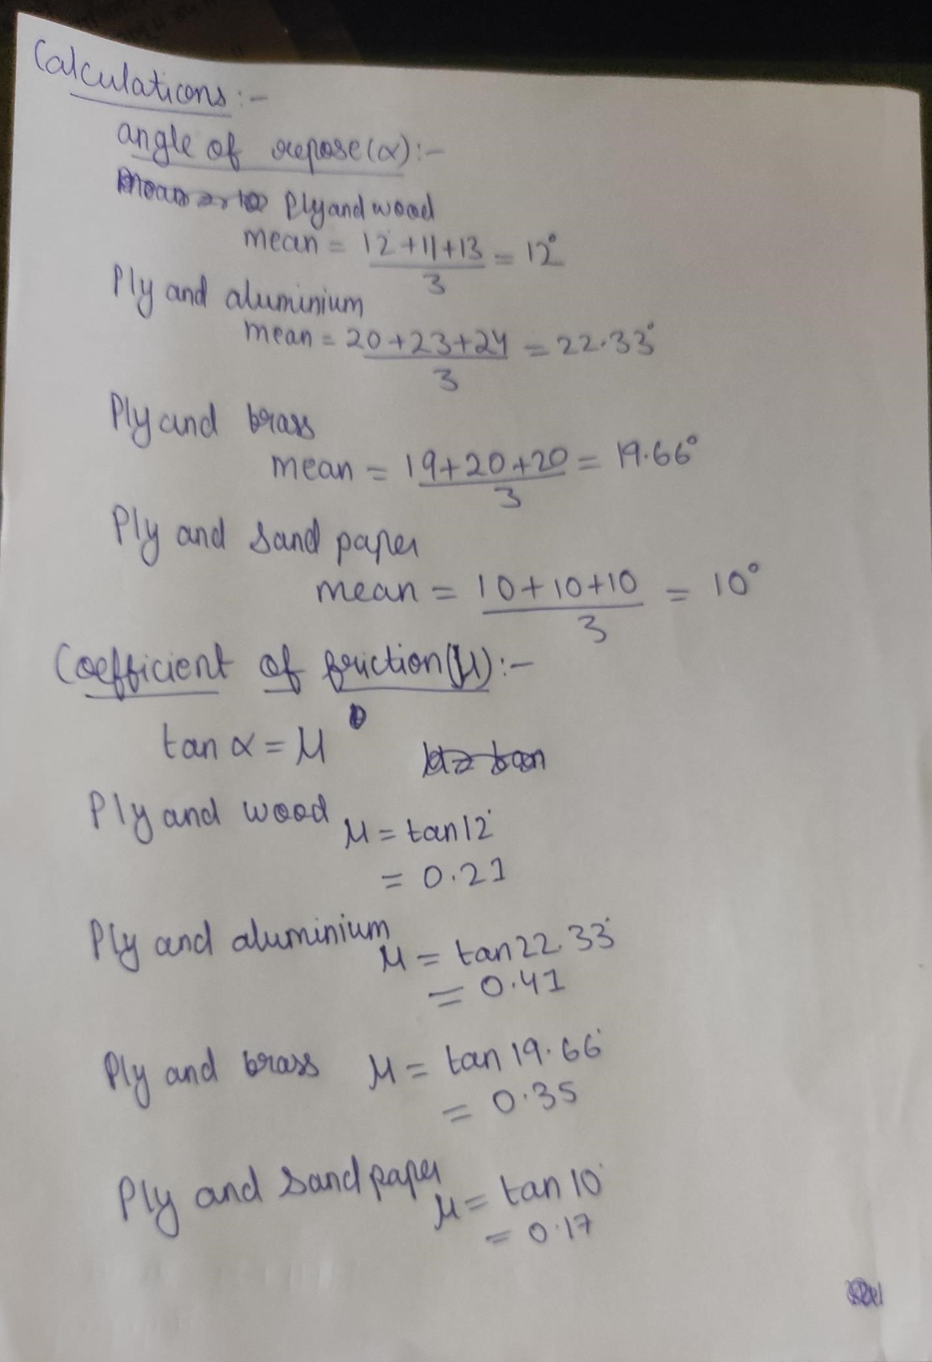

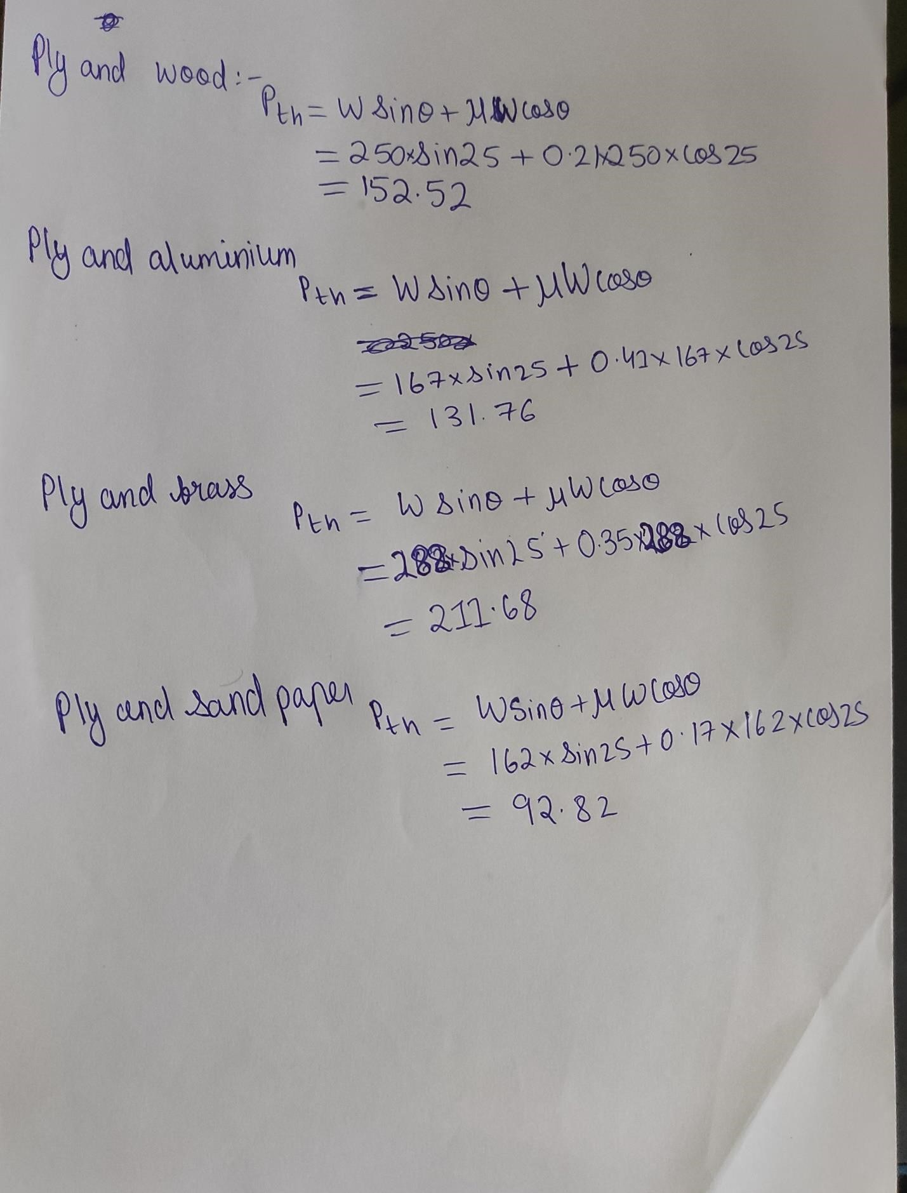

**RESULT**

Coefficient of Friction for

1. Ply and wood = 0.21
2. Ply and aluminum = 0.41
3. Ply and brass = 0.35
4. Ply and sand paper **= 0.17**

**Conclusion:**

**The experiment was taken under good circumstances. However, errors can be reduce by overlapping the mistake that was take place in this experiment. This experiment could be done exactly the same as international standard if the following conditions apply on it. First of all make sure that the hanging masses do not move while adding additional weight on load hanger. This experiment will be really useful in the future to determine the coefficient of friction for different materials.**

## Signature of faculty in-charge